Table of Contents
1. Introduction 1
2. Functionality 1
3. Designing 1
3.1 Flowchart 2
4. Module Component 2
4.1 Program Start 2
4.2 Main Module 2
4.3 Info Module 3
4.4 Purchasing Ticket Module 3
4.5 Viewing Seating Arrangement 4
4.6 Reading Module 4
5. Additional Features 5
5.1 Viewing Seating 5
5.2 File Input & Output 5
5.3 Proper Commented 5
6. Assumption 6
7. Reference 7

Introduction
This assignment is based on buying and reserving tickets for passenger for a ferry company. A small ferry company recently purchased a computer for its new automated ticketing system. We were asked by the director of the company to design a system for allocating the seat for every 50-seater on journey from Penang to Langkawi and back daily.
The ferry has the capacity of accommodating the 10 passengers at the top deck which for the business class passenger and 40 people on the main deck which is for economic class passenger. The company has 8 ferries with a unique FERRY ID each travelling its way in every one-hour interval from 10 am morning to 5 pm evening.
The system is designed in unique way to facilitate the user and the company. This system allows users (i.e. passengers) to reserve the seat, get a ticket, and know the total cost of the journey and many more. The system is designed in Python programming language and is based on HCI (Human Computer Interface). System used while making this program are Python version 3.7.1, Pyscritper 3.0, Windows 10, 64-bit and Processor Intel Core i5-3210M (3rd Gen).

Functionality
The system comprises of the following functions.
a) Sell tickets based on date and time
b) view Seating arrangement of the passenger on particular time
c) Alter the seat if passenger wants in case the Business class deck is full to economy class
d) The system is designed for the sale of ferry tickets only (i.e. no food or beverage items)

Designing
A design process charts can be used by improving communication and elimination of waste and downtime to clarify and streamline any design project. A layout for the coding part of the system was absolutely essential. It is more efficient to visualize graphically something described in words. A process by symbol and text is defined clearly in flowcharts. Furthermore, flowchart shows the process flow overview. The floating diagram i.e., Flowchart was therefore chosen as the best way to design the system blueprint. (Breezetree.com, 2019)

3.1 Flowchart
A flowchart is a schematic that shows a process, system or computer algorithm. They are commonly used to document, study, plan, improve and communicate complex processes often in various areas in clearly and easily understandable diagrams. Flowcharts, sometimes spelled as fluctuation charts, are used to define the types of steps as flow arrows and sequence definitions for rectangles, ovals, diamonds or possibly for many other forms. (Lucidchart, 2019)
A flow chart is a type of chart that represents a process by using different symbols with information about steps or sequence of events. Flowchart is also an analysis, improvement, documentation, and management methodology for a process. (Techopedia.com, 2019)

Module Component

4.1 Program Start

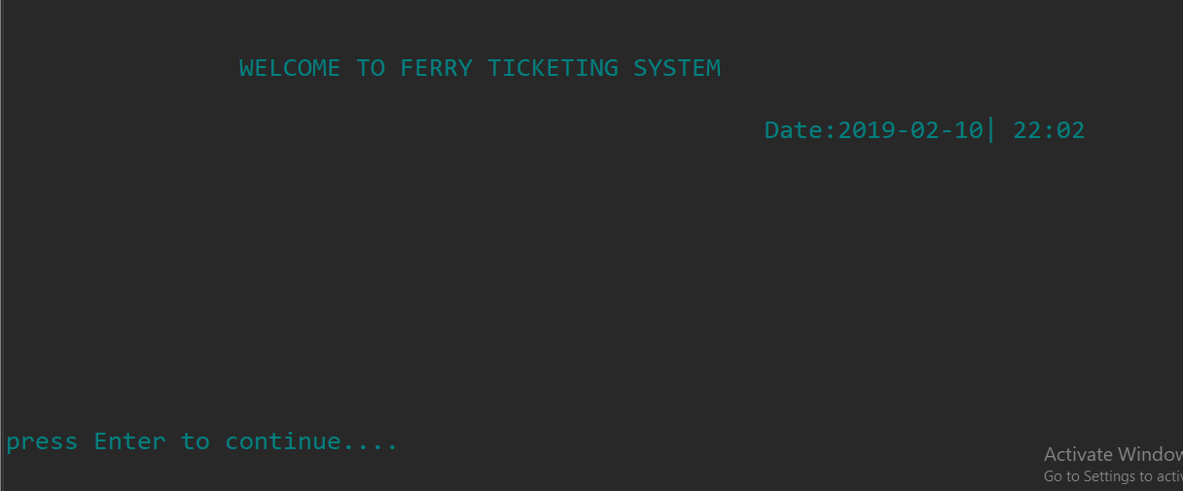
The program starts by declaring the list variables for business class and economic class as zeros. The business class list comprises of 10 elements each initializing to zero. Similarly, economic class comprises of 40 elements, all initialized to zero.

Fig: First Window that appears on running the program:

4.2 Main Module

The main module of the program simply calls the main menu which provides various information that are discussed in the info module below. Behind this, this module also reserves the ferry ID and date and time. For the date and time, it imports the external library module (i.e. import datetime, random).

4.3 Info Module

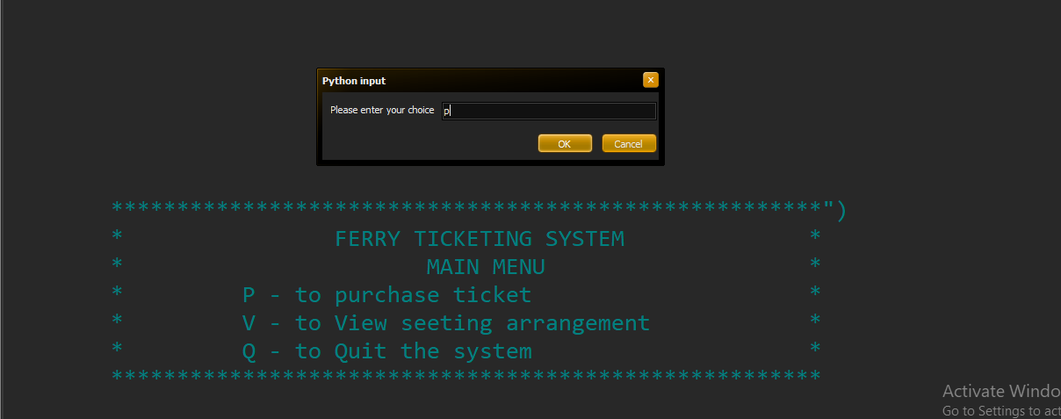
The info module gives the user to make section whether to buy tickets, view seating arrangements and quit the system. This is included in the function namely ‘menu’ The User can choose as per requirement and the program does the same.

Fig: Main Menu (Info Module)

4.4 Purchasing Ticket Module
On this module, the system provides the opportunity to select the class i.e. Business class and Economic class. After the selection is made, the system reserves the seat as per the user’s choice. The reserved seats are defined using 1 and the vacant seat is defined using 0. When the ticket is bought, the position is specified with 1.
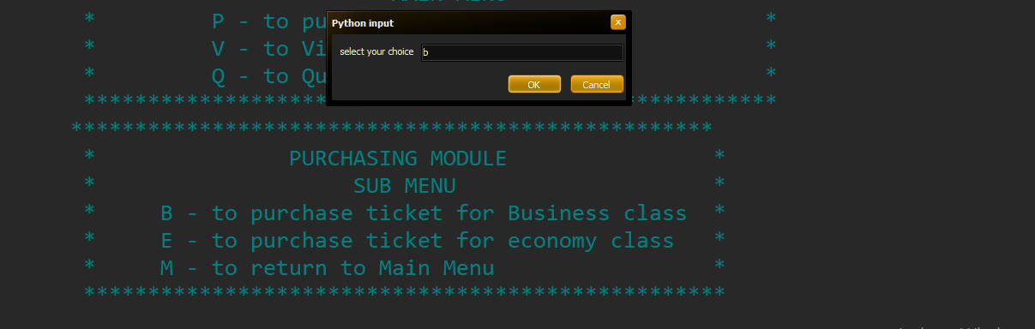

Fig: Purchasing Ticket Module

4.5 Viewing Seating Arrangement

The boarding pass for the viewers is shown in the module. It coincides with the ferry ID generated at the beginning of the program. Both the business class and the economic class of the ferry are printed on the ferry ID. This module also includes the complete boarding pass. seat.txt. On the boarding pass the current system date will be read and shown.
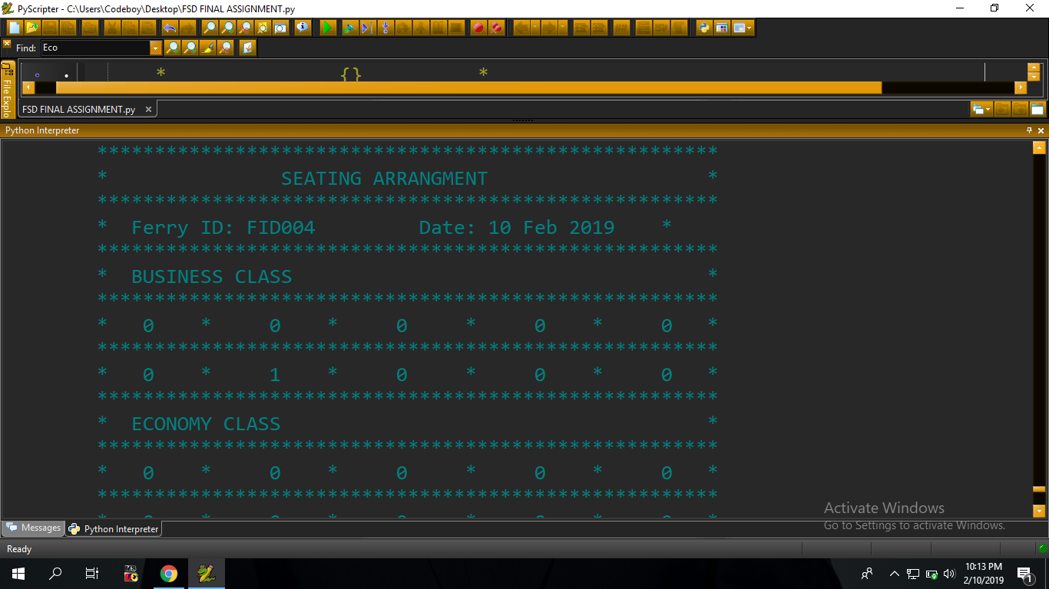
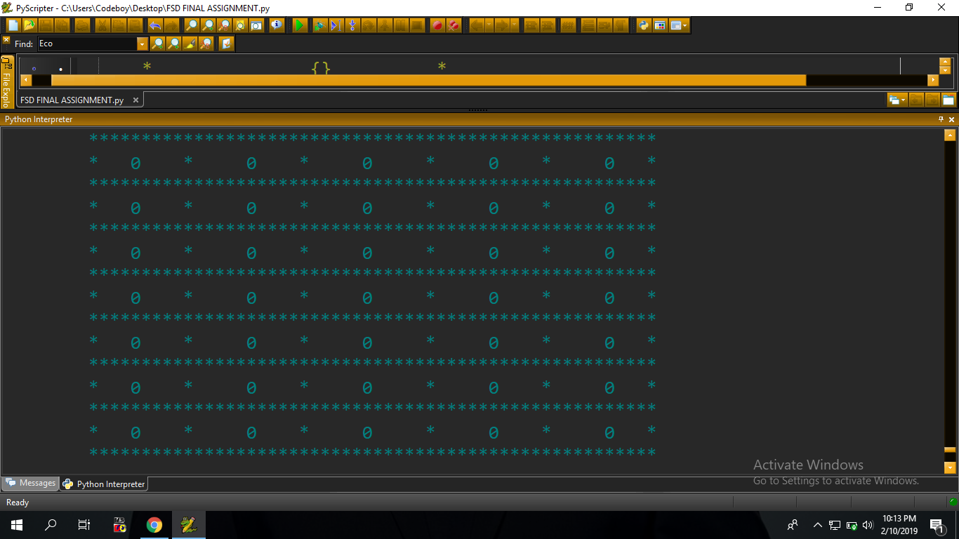

Fig: Seat Arrangement

4.6 Reading Module

The reading module allows the user to read the boarding ticket from the file named “ticket.txt” and print it on the monitor after the seat is reserved. For this, the module is kept inside a object name tickets and the method is named as getTicket.

5. Additional Features
This program enables you to view seats on the ferry selected. This module reads the current system date and shows a customer ferry identification, time of the journey, dates, business class and the ferry economy for a customer ticket that the user selects through a global flight identifier.

5.1 Viewing Seating

This program enables you to view seats on the ferry selected. This module reads the current system date and shows a customer ferry identification, time of the journey, dates, business class and the ferry economy for a customer ticket that the user selects through a global flight identifier.

5.2 File Input & Output

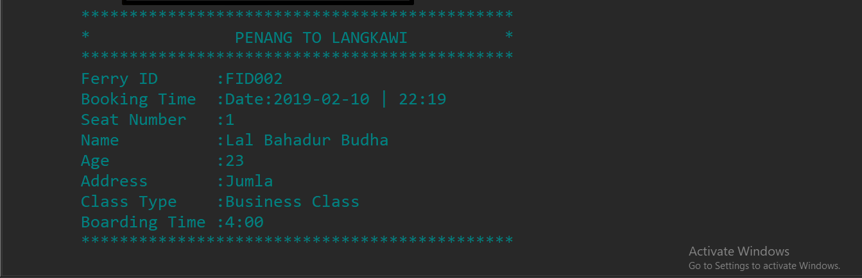
Though File input and output doesn’t seem quite useful in the program, yet some application of the file handling has been used to keep record of lastly reserved tickets and view them. This record is overwritten when the user purchases another ticket.

Fig: Ticket Details After the seat is booked

5.3 Proper Commented

The program is well maintained and properly commented. Any person can understand the logic with the help of comment that are written on the right side of some complex code.

Assumption

As a programming student I am responsible for studying frequently made (and easily avoidable) programming failures that cause potential security risks. In my experience, the wrong validation of file - read data is one of the most common flaws. It was assumed that the user will book one ticket from the entire module and then re-book more tickets on the main menu. The last reserved ferry tickets are included in the file. When the next user begins the application, the last booked tickets that have been saved on the file can be viewed. Users can reserve more than two tickets, but in the View Seat Arrangement module, you can see the latest one.

Reference

- Breezetree.com. (2019). Why Flowchart? The Top 5 Reasons for Using Flowcharts to Document Your Business Processes | BreezeTree. [online] Available at: https://www.breezetree.com/articles/top-reasons-to-flowchart [Accessed 1 Feb. 2019].
- Downey, A., Elkner, J. and Meyers, C. (2016). Learning with python. 2nd ed. Delhi: Radha Offset.
- Lucidchart. (2019). What is a Flowchart. [online] Available at: https://www.lucidchart.com/pages/what-is-a-flowchart-tutorial?a=0 [Accessed 1 Feb. 2019].
- Techopedia.com. (2019). Flowcharts. [online] Available at: https://www.techopedia.com/definition/5512/flowchart [Accessed 3 Feb. 2019].

